Submitting Vendor Payment Request (VPR) Forms

Mi Via
1.0
7/6/2023
Conduent Government Health Services
New Mexico MMIS

© 2023 Conduent, Inc. All rights reserved. Conduent and Conduent Agile Star are trademarks of Conduent, Inc. and/or its subsidiaries in the United States and/or other countries.
Other company trademarks are also acknowledged.

Version | Date | Description | Author | Approved by
v.1.0 | 7/6/2023 | Created by | Guadalupe Monge, Cerra Coffman, Robert A. Dyer | Click to enter text.

Overview

Purpose
This document reviews the process for submitting a Vendor Payment Request Form (VPR) on the Medicaid Portal.

When to Implement
This process is to be used in the following situations:
Whenever a Vendor Payment Request (VPR) Form must be submitted.

Contents
1. Overview i
1.1. Purpose i
1.2. When to Implement i
2. Contents ii
3. Procedure: Submitting Vendor Payment Request (VPR) Forms 1
3.1. How to Implement 1

Procedure: Submitting Vendor Payment Request (VPR) Forms

How to Implement
The following steps detail the process for submitting Vendor Payment Requests (VPRs) using the Medicaid Portal. This is the most efficient method of entering these requests.
NOTE: A red asterisk (*) denotes fields that must be completed to submit a request.

- Visit: https://nmmedicaid.uat.portal.conduent.com/webportal/uploadPrf
- Upon clicking the link, you will be prompted to enter your full Medicaid ID Number and select Submit.
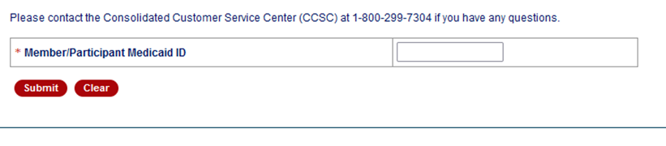
- All fields below are required, as well as adding an attachment that contains the invoice.
  - Is this a correction to a Prior VPR?
  - Have you submitted this VPR once before? If yes, please select Yes.
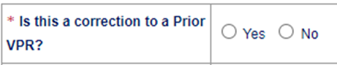
  - If no, please select No.

  - Print Member’s/Participant’s Name
  - Type Member’s/Participant’s full name
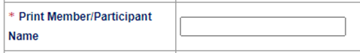

  - Enter the Approved Budget Period
  - Please list approved budget period dates that the item falls within.

  - Enter the Waiver Service Code/Modifier
  - Select approved service code on Member/Participants plan that is in alignment with item requested.

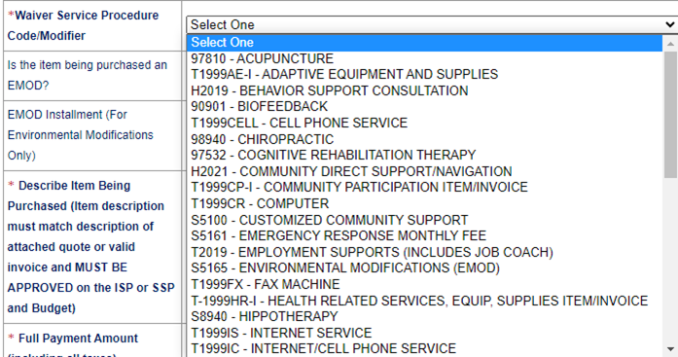

  - Describe the item being purchased (Item description must match description of attached quote or valid invoice and MUST BE APPROVED on the ISP or SSP and Budget)

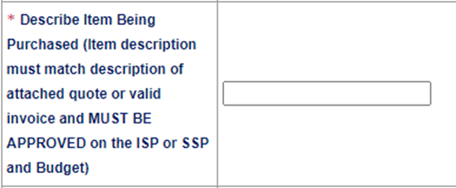

  - Enter the Full Payment Amount (including all taxes)

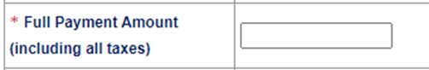

  - Enter your Desired Method of Payment
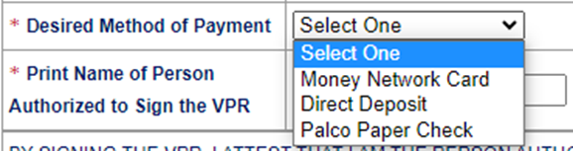
  - Enter the name of the Person Authorized to Sign the VPR
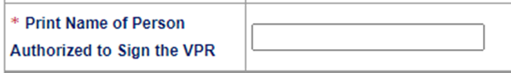

  - *Add the Signature of Person Authorized to Sign the VPR (type name to sign)
  - * Add the Payee Name (Vendor Name)
  - * Add the Request Date (This date must match the invoice date. Future dated invoices will not be accepted. Request date must be within ninety (90) days from the date of service to meet timely filing requirements.)
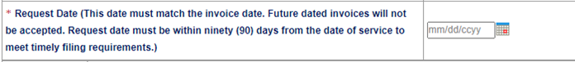
  - * Enter the Address Line 1
  - * Enter the City
  - * Enter the State
  - * Enter the Zip
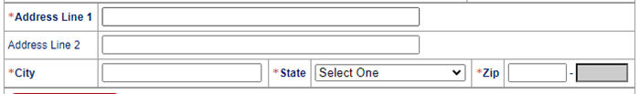

- Click on Upload Attachments
  - Locate the file on your computer, and attach the invoice
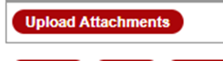

- Click Submit once all of the required fields are completed. (NOTE: The Submit option will not work correctly until each of the required fields is complete.)
